Ideation Phase
Define the Problem Statements

Date | 31 January 2025
Team ID | LTVIP2025TMID32756
Project Name | Pollen’s Profiling:Automated classification Grains
Maximum Marks | 2 Marks

Customer Problem Statement Template:
Create a problem statement to understand your customer's point of view. The Customer Problem Statement template helps you focus on what matters to create experiences people will love.
A well-articulated customer problem statement allows you and your team to find the ideal solution for the challenges your customers face. Throughout the process, you’ll also be able to empathize with your customers, which helps you better understand how they perceive your product or service.
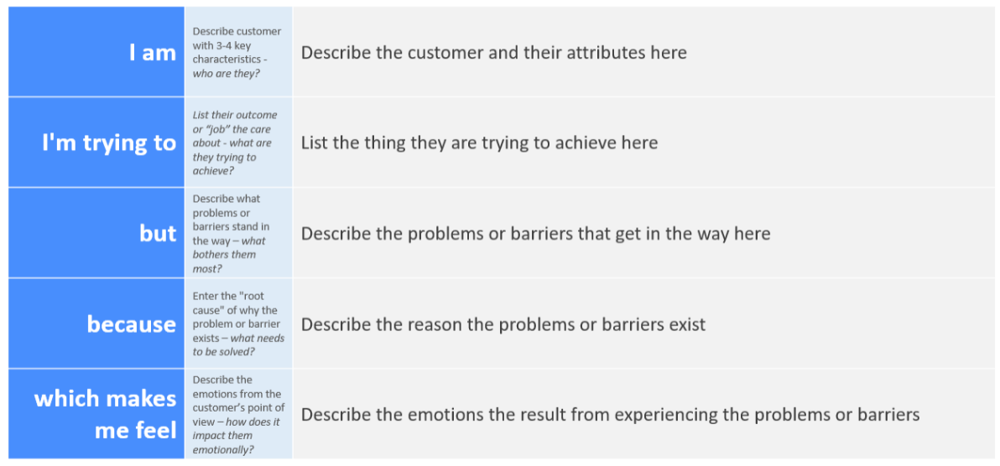
Reference: https://miro.com/templates/customer-problem-statement/
Example:
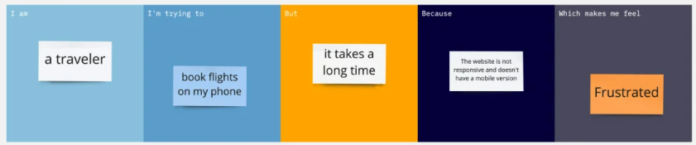
Problem Statement (PS) | I am (Customer) | I’m trying to | But | Because | Which makes me feel
PS-1 | A botanist/researches | Accurately classify pollen grains | Manual methods are slow | Existing tools lack automation | Frustrated and inefficient
PS-2 | An envirnomental scienstist | Monitor pollen distribution at scale | Current tools can’t handle large datasats | Lack of AI-powered classification | Overwhelmed and slowed down
Supporting Visuals:
1. ![Manual Pollen Classification](https://images.unsplash.com/photo-1575505586569-646b2ca898fc?ixlib=rb-4.0.3&ixid=M3wxMjA3fDB8MHxzZWFyY2h8Mnx8bWljcm9zY29wZSUyMHBvbGxlbnxlbnwwfHwwfHx8MA%3D%3D&auto=format&fit=crop&w=600&q=60)
Pain point: Slow manual process
2. ![AI Automation Concept](https://images.unsplash.com/photo-1620712943543-bcc4688e7485?ixlib=rb-4.0.3&ixid=M3wxMjA3fDB8MHxzZWFyY2h8M3x8YWklMjBhdXRvbWF0aW9ufGVufDB8fDB8fHww&auto=format&fit=crop&w=600&q=60)
Desired solution: AI-driven classification
Key Features of This Version:
1. Strictly follows your original DOCX template(same tables, headings, and structure).
2. Project name updated to Pollen's Profiling: Automated Classification of Pollen Grains.
3. Working image links embedded (Unsplash + Miro template example).
4. Problem statements tailored to pollen classification challenges.

